**Solution Architecture Document**

**Stove and Oven Application**

Document Version V1.0

Submission Date: 2/18/20

Document Control Information

|  |  |  |  |
| --- | --- | --- | --- |
| Date | File Version | Change Description | Author |
| 2/18/20 | V1.0 | Initial Document Creation | Robert Chin |

Reviewers

|  |  |  |  |  |
| --- | --- | --- | --- | --- |
| Type | Change Req # | Review Notes | Review Date | Decision |
|  |  |  |  |  |

Table of Contents

1. Overview 3

1.1 Executive Overview 3

2. Architecture Exceptions & Tech Debt 3

2.1 Exceptions 3

3. Applications and Technology 3

3.1 Applications 3

3.2 Technologies 3

4. Requirements 4

4.1 Reference Architecture Mapping 4

4.2 System Quality Attributes / Non-Functional Requirements 4

4.3 Monitoring Requirements 7

4.4 Capacity Estimates and Summary 7

4.5 Performance Requirements 9

5. Solution Overview 9

5.1 RAID Analysis 9

5.2 Architecture Release Strategy 10

5.3 Solution Architecture Views 10

5.3.1 Context / Logical View 10

5.3.2 Process View 10

5.3.3 Development View 11

5.3.4 Physical View 11

5.3.5 Operational View 12

5.3.6 Security View 12

5.4 Security Architecture 13

5.5 Data Architecture 14

5.5.1 Data References 14

5.6 Solution Integrations 15

5.6.1 API Integration Catalogue 15

5.6.2 Data Integrations 15

6. Accessibility Assessment 15

7. Glossary 15

8. References 15

9. Appendix 15

# Overview

## Executive Overview

Last semester we had developed a MVP for the Stove and Oven web application. It was a tool designed and developed to help users plan their weekly meal prep by providing some recipe examples. The tool also accounted for their refrigerator / ingredients they had, and accounted for key user attributes like favorites and meal preferences.

This semester we will look at additional features, performance scaling, productionizing, and security of the application./

# Architecture Exceptions & Tech Debt

## Exceptions

|  |  |  |
| --- | --- | --- |
| # | Description | Link |
|  |  |  |

There are no predefined target standard architectures / technologies requiring exceptions.

# Applications and Technology

## Applications

|  |  |
| --- | --- |
| Application Name | Architecture Requirements / Exceptions from Application Development Team |
| Stove and Oven |  |

## Technologies

|  |  |  |
| --- | --- | --- |
| Manufacturer | Product Name | Version |
| NodeJS |  |  |
| ExpressJS |  |  |
| ReactJS |  |  |
| Heroku |  |  |
| MongoDB |  |  |

# Requirements

## Reference Architecture Mapping

|  |
| --- |
| Alignment Comments |
|  |

## System Quality Attributes / Non-Functional Requirements

|  |  |  |  |
| --- | --- | --- | --- |
| Category | Attribute | Description | Explain Approach and if there are any tradeoffs or tech debt to meet the requirement (if applicable) |
| Usage | Usability | Effectiveness for consumer | The team will do some usability testing |
|  | Localization | Experience tailored to region | The recipes are broad, accounting for certain dietary constraints/restrictions, but not regional.  It could deter certain types of users, but you don’t have to search by dietary constraints or restrictions |
|  | Accessibility | Support for disabled users | N/A |
|  | Personalization / Customizability | Audience specific experience | Users are able to account for their favorite recipes and profile pic, and meal plan / refrigerator ingredients |
|  | Reusability | Potential to save additional development effort | The Express API provides an avenue for if another kind of web application to query our lists of recipes publicly. |
|  | Configurability | Runtime behavior modification |  |
|  | Interoperability | Ease of information exchange | The exchange of information is done via HTTP/S APIs (for the React and Express) |
| Development | Manageability | Build process, source code and tooling alignment |  |
|  | Maintainability / Upgradeability / Flexibility / Agility | Ease of rapid change | Any code committed/pushed to the Github is compiled onto the Staging website  Additional work to create Production site (TBD) |
|  | Extensibility | Ease of adding functionality | The web application is open-sourced on Github. People can choose to add / modify code, as long as you’re granted the access. |
|  | Testability | Ensure functionality per specification |  |
| Operation | Performance | Responsiveness at least per SLA |  |
|  | Reliability / Availability / Resiliency | Usage window and mean time to failure (see metal rating) |  |
|  | Scalability | Increase throughput without reducing performance |  |
|  | Recoverability | Failure response complexity and SLA |  |
|  | Supportability | Ease of: deployment, operation, monitoring, debugging, or environment change (portability) |  |
| Security | Auditability | Track activity in all tiers | The tracking of users happens at the Heroku and the MongoDB  You could add user account management for the customer users, but additional tooling would need to be developed. |
|  | Attack surface area | All vectors that can be exploited | This is a web application.  All components are hosted on Internet, and communicate over Internet  HTTPS encryption between User/React, React/Express (TBD) or the mongo+srv between Express and DB  Proper whitelist controls should be implemented on Mongo, and or Express services. |
|  | Lease Privilege / Default Configs and Permissions | No user or process can do more than they should | RBAC on the Heroku for React and Express (Enterprise, if added), RBAC on the MongoDB  Users only can access their profile’s information. |
|  | Fail Securely | Protect from data leak or failure cascade |  |
| Tradeoffs |  | EX: Performance vs Maintainability, Interoperability vs Configurability |  |
| Other |  |  |  |

## Monitoring Requirements

|  |  |  |
| --- | --- | --- |
| Platform | Review Items | Response |
| On-Prem Application | Confirm that existing monitoring capabilities can handle all requirements? | N/A – Not On-Premises |
|  | Does this application involve any non-standard data sources? | N/A – Not On-Premises |
|  | List of Health Checks which need to be in place. E.g. Server startup, load balancer verification, message broker, web tier, batch trail, etc | N/A – Not On-Premises |
|  | Does the solution involve any batch functionality or peak times which would be recognized? | N/A – Not On-Premises |
| SaaS / Hosted | Does the solution come with native monitoring and performance management we can pull using open API? | Heroku and MongoDB have dashboards for monitoring and performance management.  Heroku Logplex  MongoDB project Events could be retrieved using API |
|  | Can the solution send events natively to our event management system? | Yes, this is possible. But we don’t have an event management system |
|  | Are internal users required to log on to vendor applications to check monitoring dashboards or correct issues? | Yes, unless integration with to be developed centralized event management / operational support systems |

## Capacity Estimates and Summary

|  |  |  |
| --- | --- | --- |
| Characteristics | Target value | Constraints / Notes |
| Total number of users | 10 | MongoDB user DB collection support 10 users  If Google Auth has a cap on how many users can authenticate through it |
| Number of concurrent sessions | 10 | Load Balanced ReactJS Heroku, Load Balanced ExpressJS Heroku |
| Number of total transactions per day | 100 | Added the inquiry and updates. |
| Number of inquiry transactions per day | 50 | Number of GET commands that happen on the Express to populate frontend React  This also probably isn’t an average |
| Number of update transactions per day | 50 | Number of PUT/DELETE commands that happen on the Express to populate Refrigerator, Favorites, Meal Plan  However, this probably isn’t an average (but rather once a week) |
| Batch processing windows | N/A | On a usual basis, our recipes are not batch updated from the Spoonacular API.  However, when doing so updating the Recipe DB should have a batch processing window. |
| % annual transaction increase | 1% |  |
| % annual data volume increase | 1% |  |
| Supported years of expansion | Only 6 months for until the end of this semester | Stevens Spring 2020 |

## Performance Requirements

These types of requirements should be discussed with the developers, I put placeholders.

|  |  |  |
| --- | --- | --- |
| Characteristics | Target Expectation | Constraints / Notes |
| Integration Response time for inquiry transactions | X sec | API interface System A to Sys B |
| Max utilization rate | X% | Headroom threshold |
| Response Time to Establish User Session | Less than X minutes |  |
| Response Time for Inquiry Transactions | X secs | From cold start |
| Response Time for Update Transactions | X secs | Per leg of transaction |
| Timeout if no response from host | X minutes |  |
| Log out if idle | X minutes |  |
| Max utilization Rate | X% |  |
| Response Time to get a report for viewing | X secs |  |
| Max Utilization Rate | X% |  |

# Solution Overview

## RAID Analysis

|  |  |  |  |  |
| --- | --- | --- | --- | --- |
| Item | Description | Type (Risk, Assumption, Issue, Dependency) | Criticality | Next Actions / Decisions / Status |
| 1 | Refactoring of ExpressJS code to support multiple databases | Dependency | High |  |
| 2 | Creation of new MongoDB Cloud Atlas accounts / projects | Dependency | High |  |
| 3 | Investigation of cost/benefits of Heroku Enterprise to support LB | Risk | High |  |
| 4 |  |  |  |  |

## Architecture Release Strategy

|  |
| --- |
| Release Strategy |
|  |

## Solution Architecture Views

### Context / Logical View

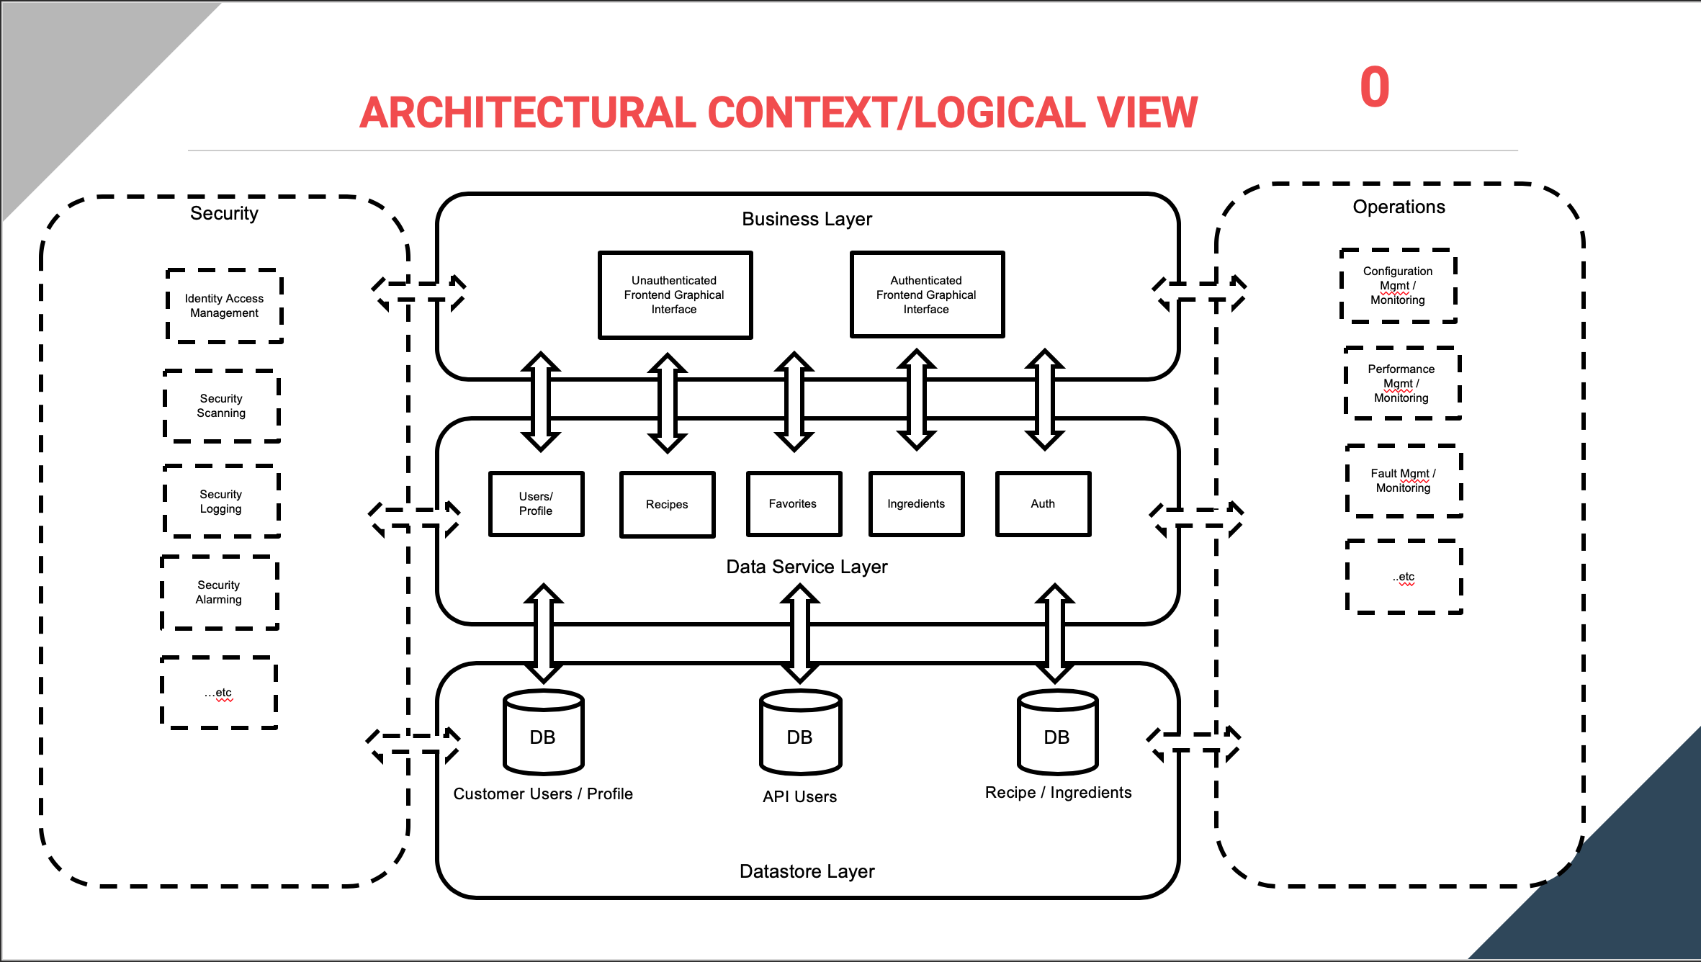

### Process View

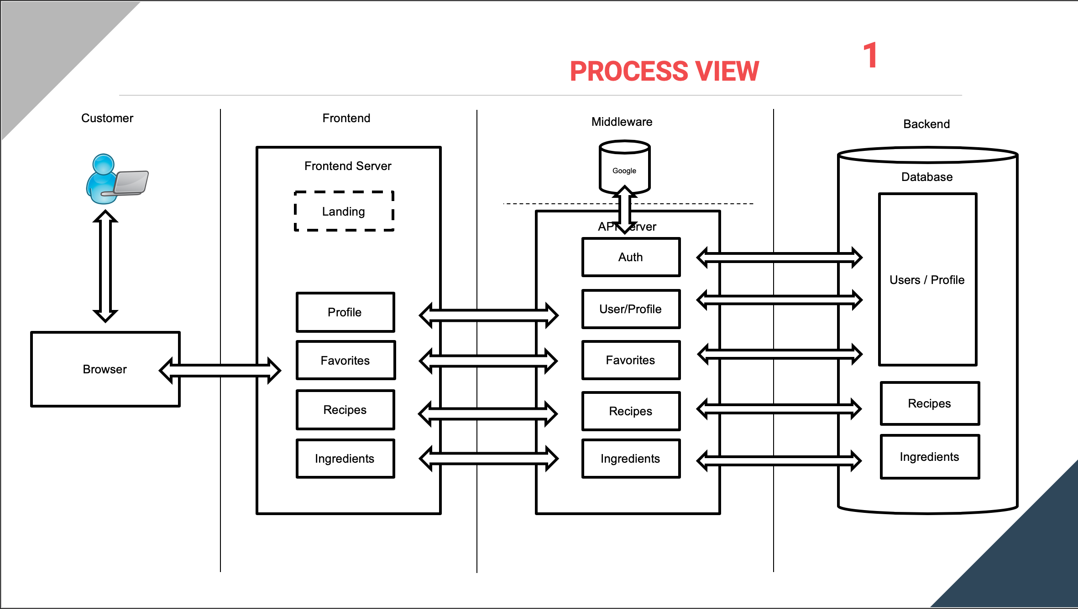

### Development View

The existing application/system consists of:

1. ReactJS 16.7.0
2. ExpressJS 4.17.1
3. NodeJS v10.x
4. MongoDB Cloud Atlas / MongoDB 4.2

### Physical View

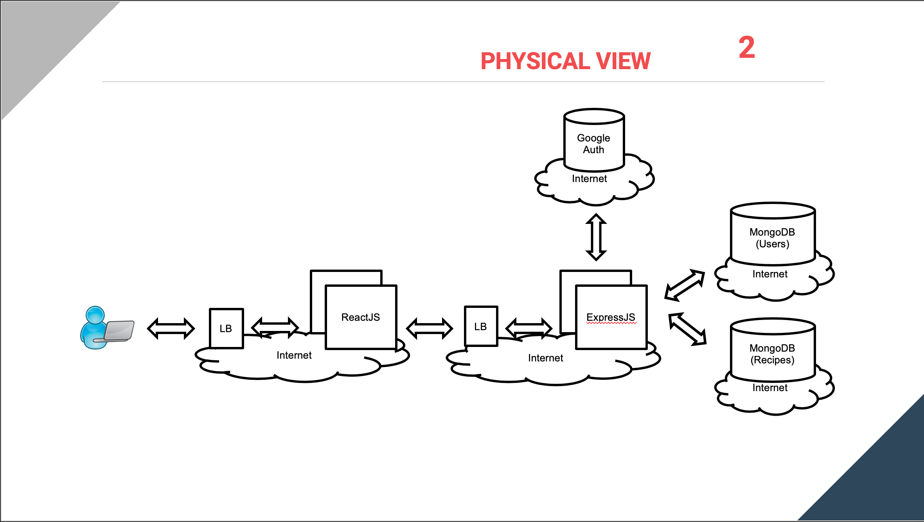

### Operational View

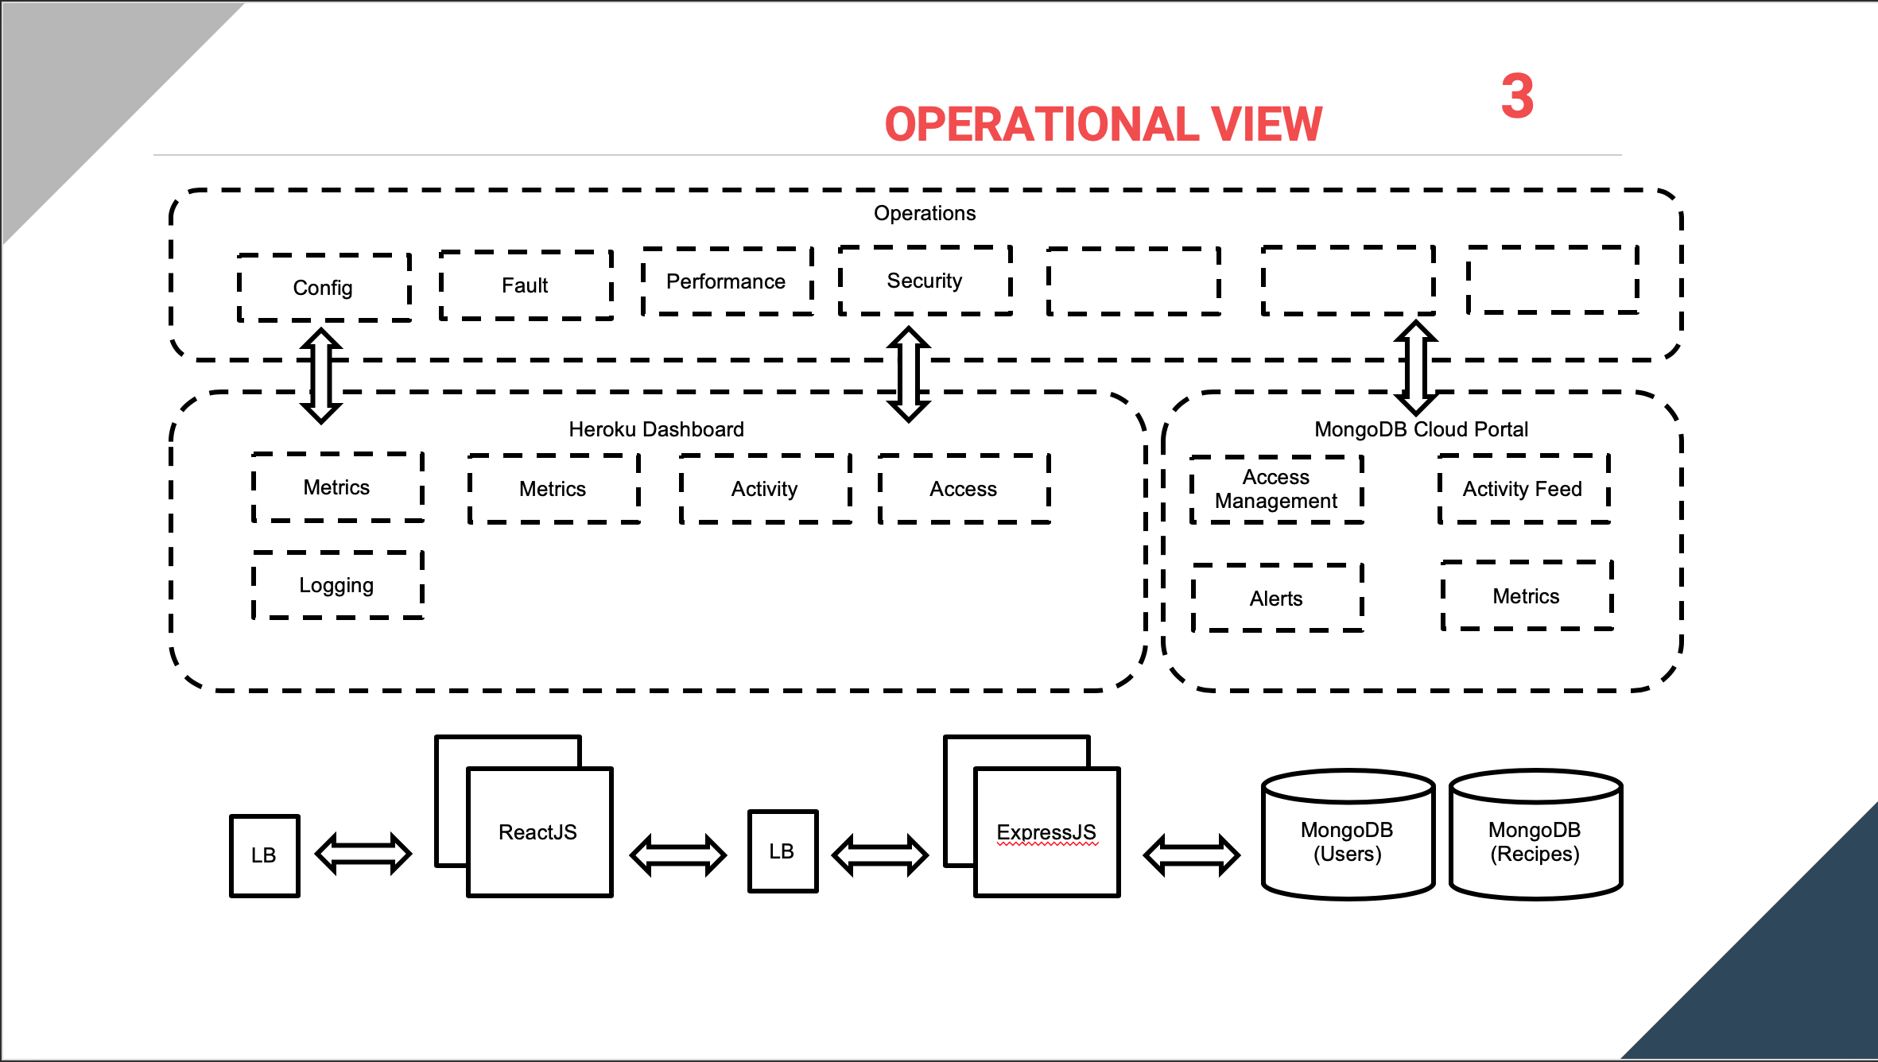

### Security View

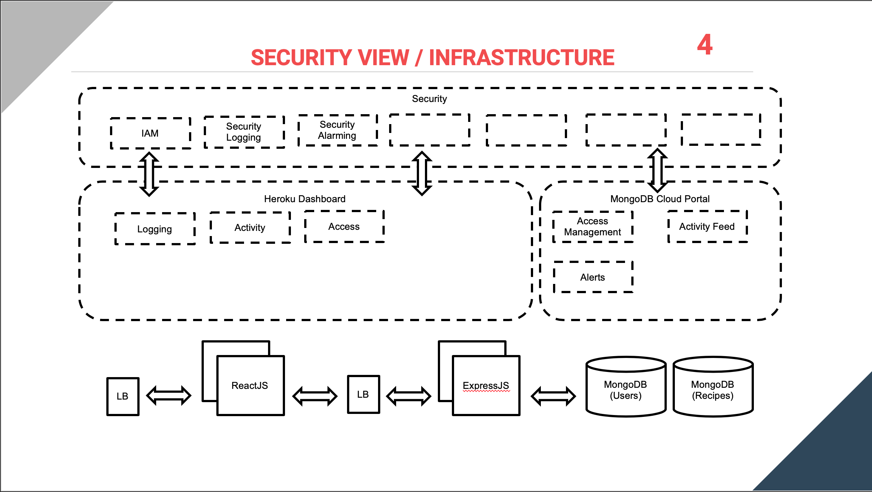

## Security Architecture

|  |  |
| --- | --- |
| Question | Response |
| How will SSO be implemented? | The customer authentication is done via a Google Auth.  There are plans for local customer authentication.  No, SSO will not be implemented. |
| Describe how the solution is leveraging API security standards? | OWASP API standards should be considered when developing  <https://owasp.org/www-project-api-security/> |
| What secure channels are being used for file transfer (ex. sftp)? | There’s no file transfer happening, but HTTPS is should be used |
| If data at rest will be stored somewhere other than an internal managed store (ex. Vendor hosted, or cloud hosted), please list and describe the encryption methods used (ex. AES-256) and provide other security protections | Currently, data is stored not internally managed but on MongoDB Cloud Atlas.  Cost/Benefit analysis to enable encryption of data at rest should be investigated |
| Describe the encryption method for data in transit (ex. TLS 1.2) | Data to the user is HTTPS / TLS 1.2  Data between Express and DB (TLS 1.2) |
| If the solution has External User facing sites, is Multi-Factor Authentication (MFA) enabled? | No. |

|  |  |  |  |
| --- | --- | --- | --- |
| User Type | User Role | Authorization | Certification and Recertification |
|  |  |  |  |

Heroku Access (Enterprise version)

1. View
2. Deploy
3. Operate
4. Manage

MongoDB Cloud Atlas Project Access:

1. Project Owner / Cluster Mgr
2. Data Access (R)
3. Data Access (RW)
4. Project (R)

## Data Architecture

### Data References

The application’s data consists of:

1. User Profile
   1. Credentials
   2. Favorites
   3. Ingredients in their Refrigerator
2. Recipe / Ingredient Data

The User Profile’s Credentials should consider encryption methods in database

The rest of the data where feasible could also consider encryption at rest, but not necessary – it’s public data. You could consider more secure handling of a User’s private information of ingredients in their Fridge or their favorites

## Solution Integrations

### API Integration Catalogue

N/A

### Data Integrations

N/A

# Accessibility Assessment

|  |  |
| --- | --- |
| Question | Response |
| Does your application / project / solution involve an external facing web application | Yes |
| Does your (application / project / mobile app) comply with the respective country’s Web Accessibility Laws and Policies? |  |

# Glossary

|  |  |
| --- | --- |
| Terms | Definitions |
|  |  |

# References

|  |  |
| --- | --- |
| Item | Link / Reference Source |
|  |  |

# Appendix